Changelog
Version ID | Change Made | Screenshot | Comments
VID# | [] | []
VID1  products.json | Here I created the array of products for my website. This included JSON dictionaries to store the specs of different cars | 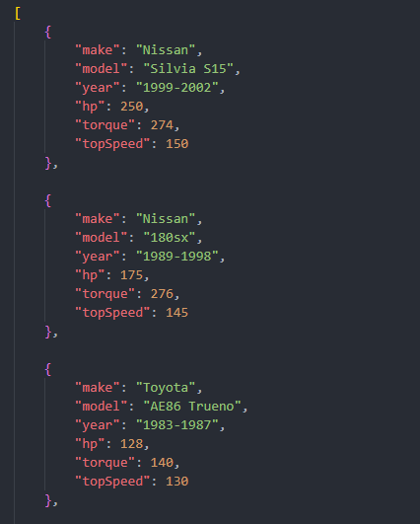
VID2  Index.html | Started the index html, set the name, linked the javascript + css and set the title. | 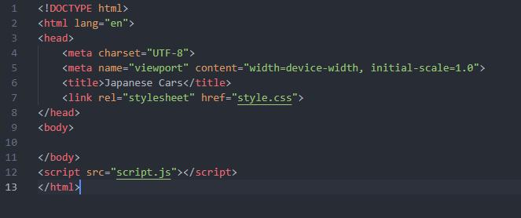
VID3  Index.html  style.css | Added the header + styling to the website | 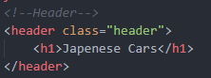  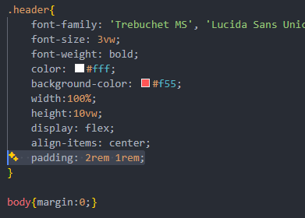  
VID4  Index.html  style.css | Added the ul element and styling – uses li tags for testing the looks. | 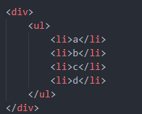  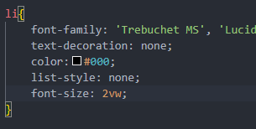  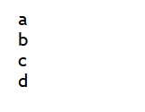
VID5  Index.html  style.css | Designed the list item to store all the information and updated css to do so. | 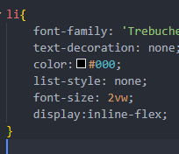  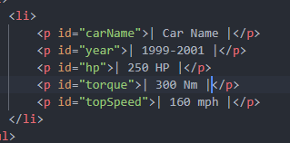  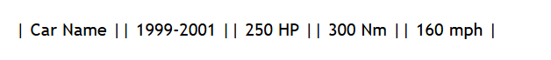
VID6  Script.js | Here I started working on the javascript to fetch the array from the JSON. | 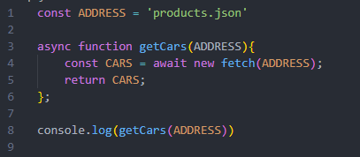 | Tested in TID1
VID7  Script.js | Here I removed the ‘new’ command | 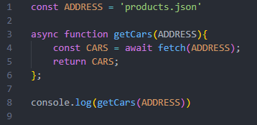 | Tested in TID1.1
VID8  Script.js | Here I added the ‘.JSON()’ to the response from the fetch and changed the variable names to better suit their purpose. | 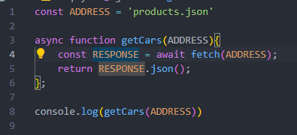  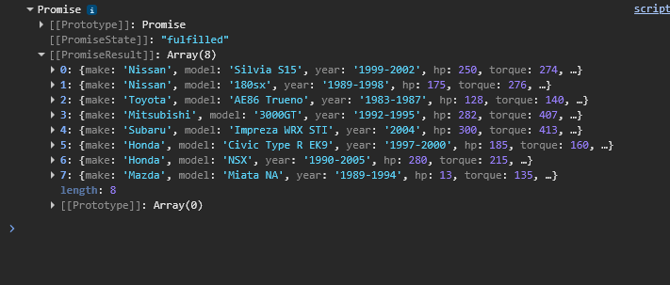 | Tested in TID1.2
VID9  Script.js | Here I prepared the rest of the functions and the initialisation of the functions | 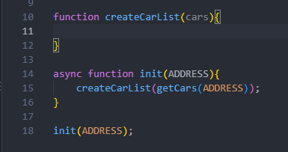
VID10  Index.html  Script.js | Here I added an id to the unordered list so it could then be searched for in the JS function. After it is searched for, a for loop runs through each of the cars in the JSON file. Then all relevant p tags are created. | 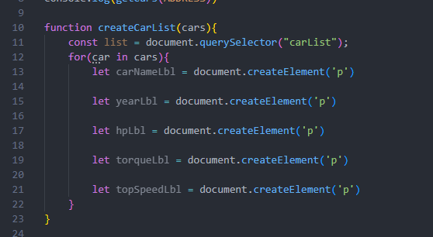
VID11  Script.js | Here I added a creation for the li element to act as a container, the car name p tag would then get its text set and the appropriate appendages would take place. Every loop the program will log to the console as a debugging tool. | 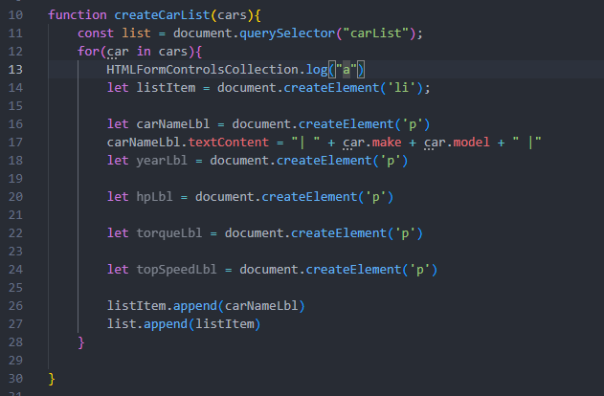 | Tested in TID2
VID12  Script.js | Fixes the console log as the wrong command filled in during typing. | 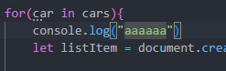 | Tested in TID2.1
VID13  Script.js | After adding an additional console log for further testing, the program still didn’t work. | 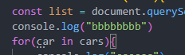
VID14  Script.js | Added the ‘await’ command to the function call so that the function wouldn’t be called before the data was ready. | 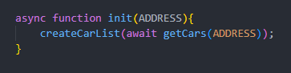 | Tested in TID2.2
VID15  Script.js | Here I moved around the console logs to better understand where the problem is. | 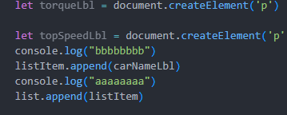 | Tested in TID2.3
VID16  Script.js | Added an extra log to check what is in the contents of this car variable used in the for loop | 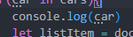 | Tested in TID2.4
VID17  Script.js | Adjusted the for loop to the correct syntax for the desired outcome |  | Tested in TID2.5
VID18 | Added a console log to ensure the syntax of my data fetching was correct. |  | Tested in TID3
VID19  Script.js | The # to resemble that it is an ID it is searching for was missing so now that has been added | 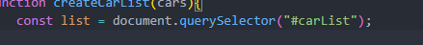  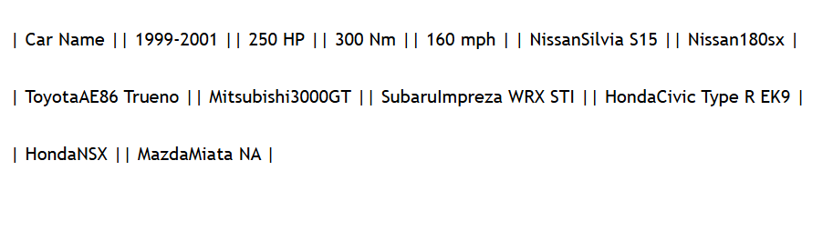 | Tested in TID3.1
VID20  Script.js | During further development I realised using an li tag and then a div tag within that so that the formatting is correct | 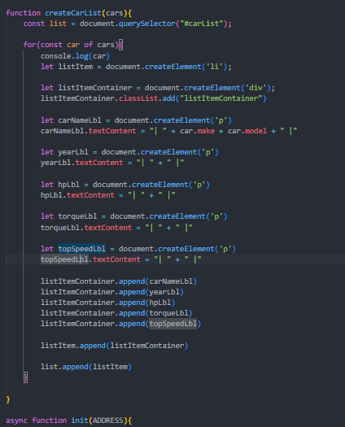  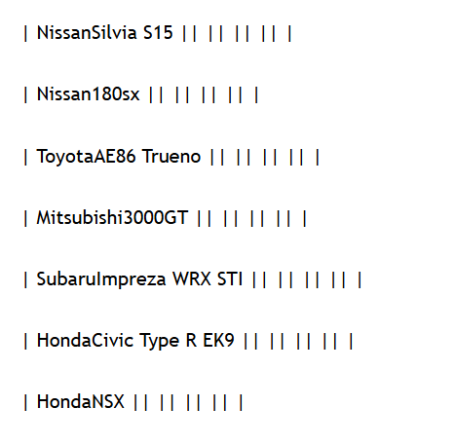 | Tested in TID4
VID21 | Here I added the rest of the info and ensured the is a space between the make and model. | 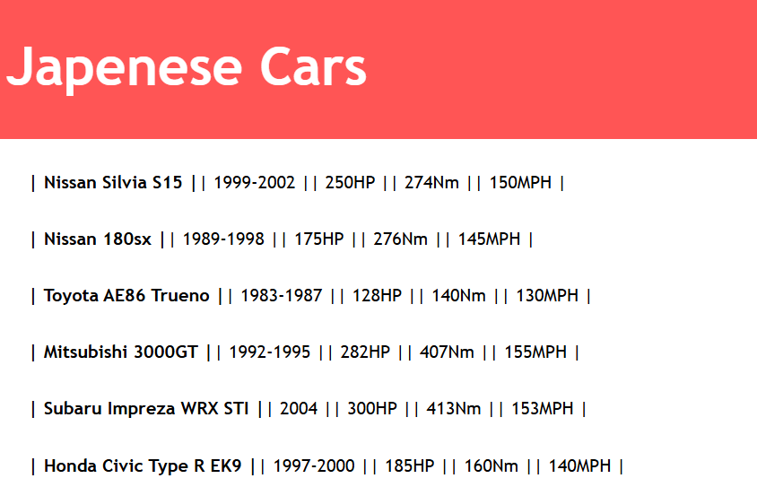
VID22  style.css | Here I updated and improved the css to build a better display for the products. | 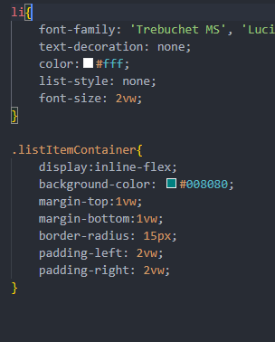  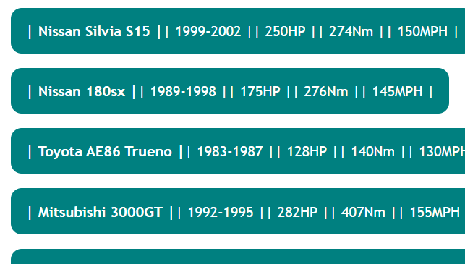 | This makes this format for displaying the information much simpler and more succinct.
VID23  Products.json  27/10/26 | Now that the proof of concept is complete I have now moved on to starting to display this information in a card format. For this I added more information to the JSON. | 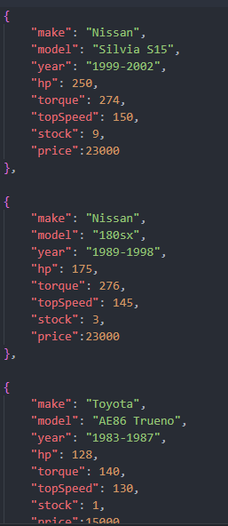
VID24  gridtest.html  27/10/26 | Here I created a new html file for testing the basic development of the grid of products. | 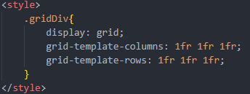  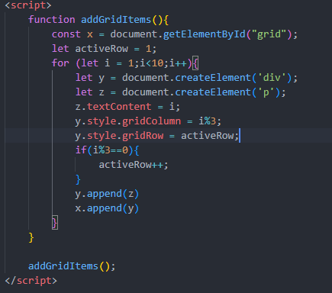  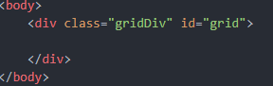 | Tested in TID5
VID25  script.js  27/10/26 | Here I applied the logic from the testing html to the actual website | 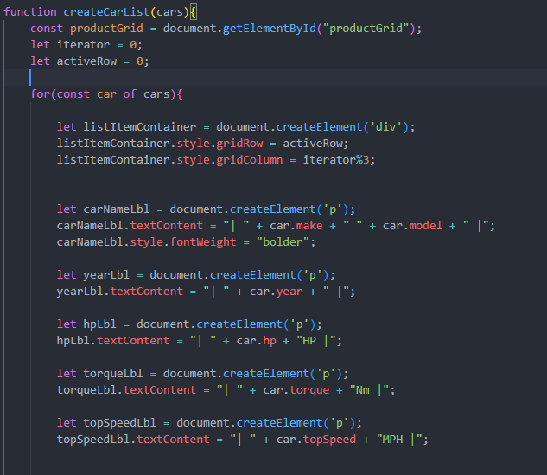  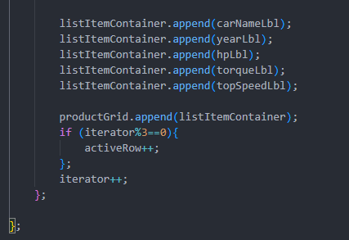 | Tested in TID6
VID26  script.js  style.css  27/10/26 | Here I adjusted the looks of the info cards and added additional info. | 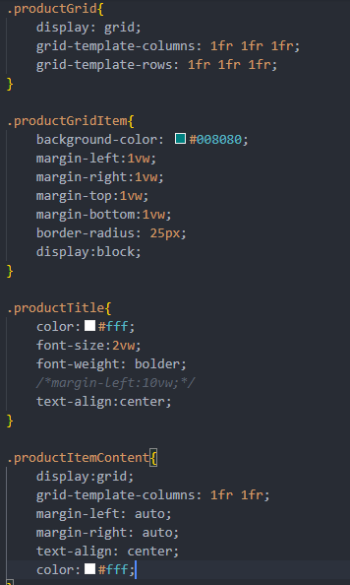  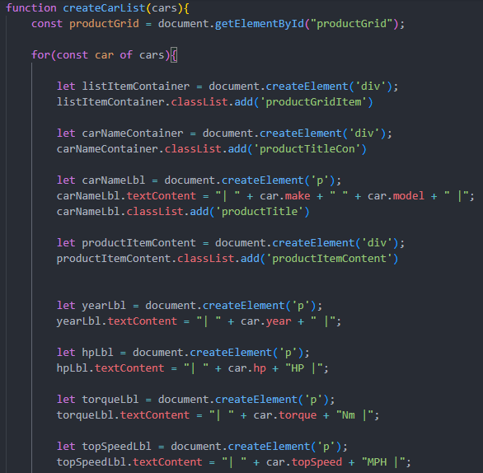  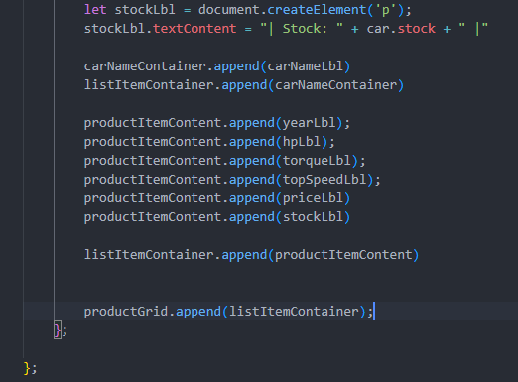  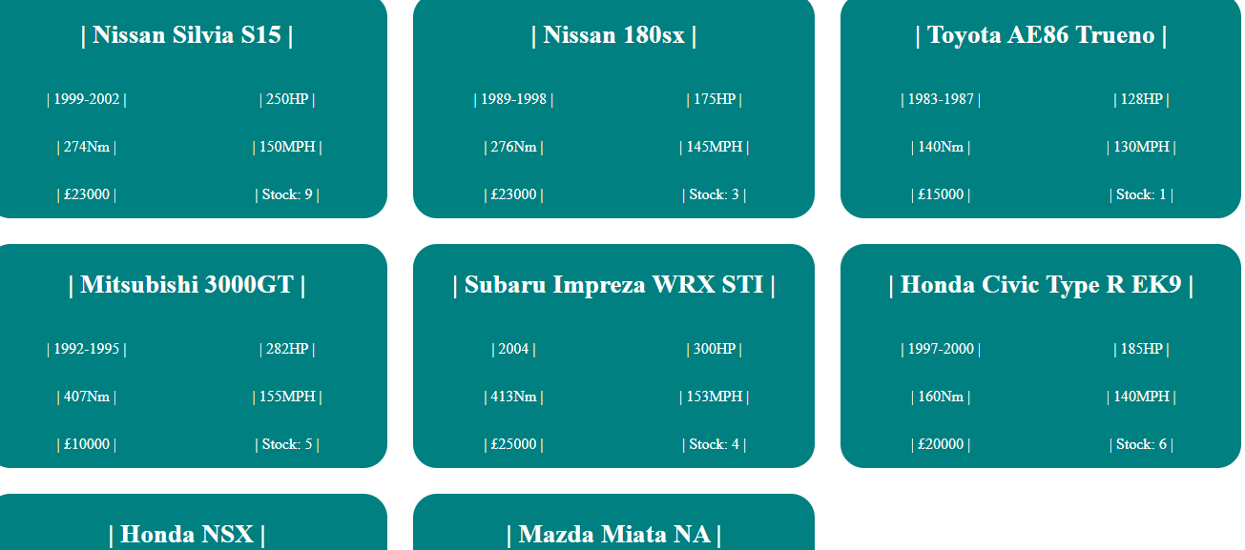 | During the development of this version I noticed that there is no need for the over engineered grid location allocation and will do this automatically. Therefore the original code for this has been removed.
VID27  Index.html  27/10/26 | Here I have started to add a filter. | 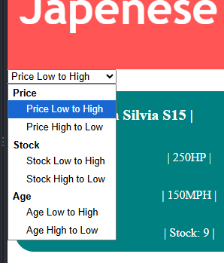  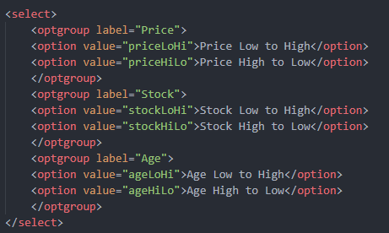
VID28  Script.js  27/10/26 | Here I have started the javascript for the drop down.  All that is left is figuring out how to sort the items of the JSON file as there is many cases where FILTER.value does not work | 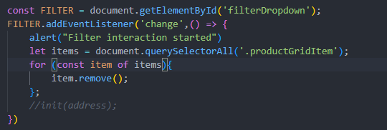
VID29  Script.js  27/10/26 | Here I have developed the code to sort the cars based on each of the filters. Now I must figure out how to call each sort. | 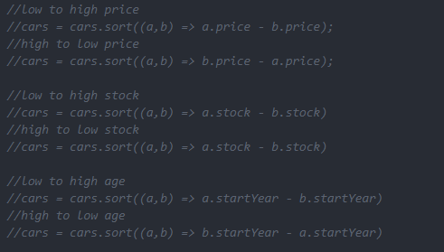 | Tested in TID7
VID30  Script.js  27/10/26 | Here I have added the sorting algorithms to a switch case within the arrow function of the event listener with alerts to test the different stages of the code | 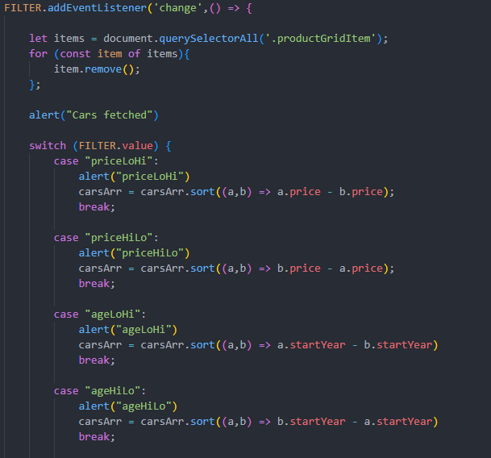 | Tested in TID8
VID31  script.js  27/10/26 | Here I completed the suggestions made by copilot which then lead to the program working as expected.  The fix was making the arrow function an async function which then allowed the function call to be awaited. | 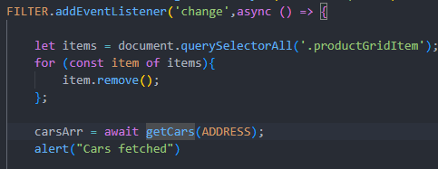 | Tested in TID9
VID32  script.js  27/10/26 | Here I removed the alerts that were added for testing so that the program works more seamlessly. | 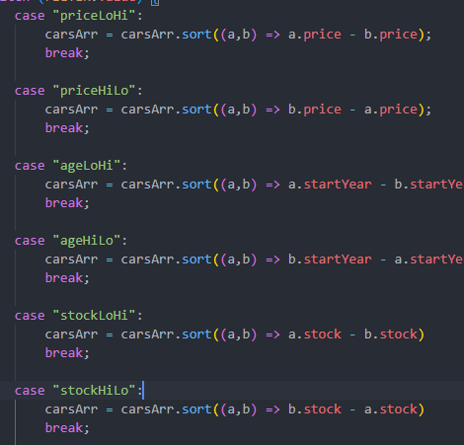
VID33  Script.js  Index.html  Style.css  28/10/26 | Started creating a cart. This cart will only be viewable on this page as a proof of concept. | 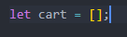  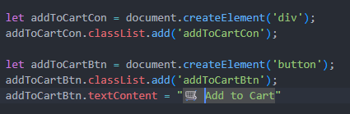  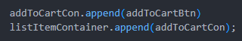  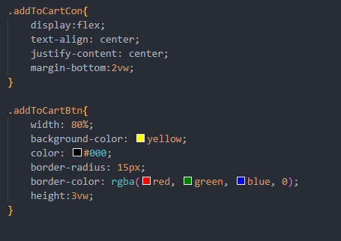  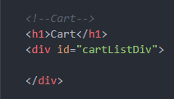
VID34  script.js  products.json  28/10/26 | Here I added the event listener and the cart functionality.  I have added the alerts for testing and the .model within the push command for testing of the syntax | 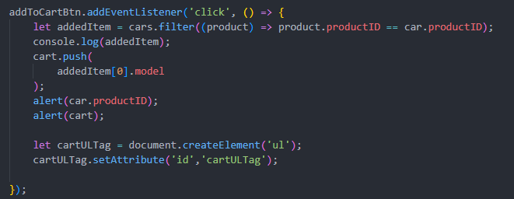  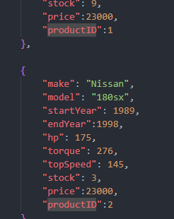 | Tested in TID10
VID35  Script.js  Index.html  28/10/26 | Here I added the updating to the cart ul tag using the for loop to iterate through all the items. Also I sorted the cart array by product ID so that it is more organised.  This code also required me to add a ul tag with the id so that when the program runs it has something to delete rather than null. | 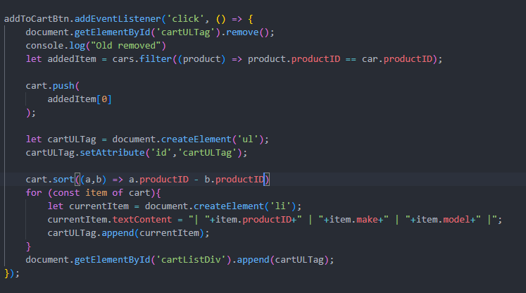  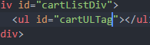
VID36 | Here I started the area to total the cost of all the items in the cart | 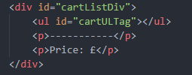  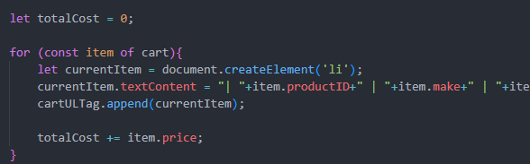  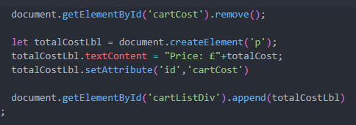 | Tested in TID11
VID37 | Here I added the new price label to the list of items in the users cart. | Before:  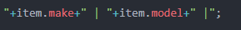  After:  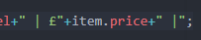  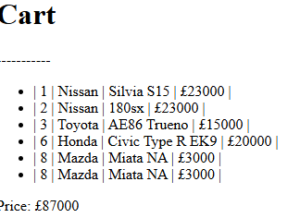
VID38 | Here I updated all files to be fully commented | 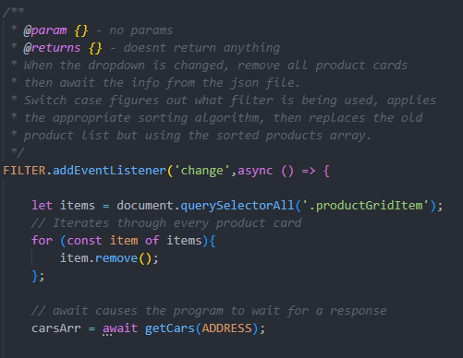  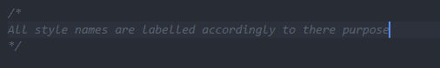  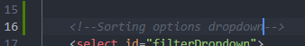  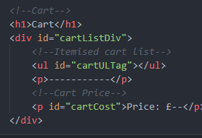

Test log
Test ID | Test to be made | Test data used | Type of test | Expected result | Actual Result | Comments
TID1 | Does the code fetch and log an array | N/A | Unit Test | An array is visible in the console | An error is thrown on line 4
TID1.1 | Does the code fetch and log an array | N/A | Unit Test | An array is visible in the console | There is no error but the log does not contain the array
TID1.2 | Does the code fetch and log an array | N/A | Unit Test | An array is visible in the console | An array is visible in the console
TID2 | Does the ul tag update and log the console | N/A | Unit Test | Console logs every iteration of the loop and adds content relevantly | Did not update the UL tag or log to console
TID2.1 | Does the ul tag update and log the console | N/A | Unit Test | Console logs every iteration of the loop and adds content relevantly | Did not update the UL tag or log to console
TID2.2 | Does the ul tag update and log the console | N/A | Unit Test | Console logs every iteration of the loop and adds content relevantly | Console logs for one loop but then throughs an error.
TID2.3 | Does the ul tag update and log the console | N/A | Unit Test | Console logs every iteration of the loop and adds content relevantly | 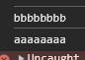  Both logs are sent but an error is thrown on line 28
TID2.4 | Does the ul tag update and log the console | N/A | Unit Test | Console logs the contents of the selected item of the array | The variable does not store the expected information.
TID2.5 | Does the ul tag update and log the console | N/A | Unit Test | Console logs the contents of the selected item of the array | Console logs the contents of the selected item of the array 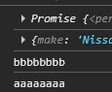
TID3 | Does the ul tag update and log the console | N/A | Unit Test | Console logs every iteration of the loop and adds content relevantly | 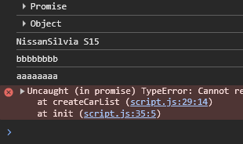
TID3.1 | Does the ul tag update and log the console | N/A | Unit Test | Console logs every iteration of the loop and adds content relevantly | Console logs every iteration of the loop and adds content relevantly
TID4 | Does the list items display properly as intended. | N/A | Unit Test | List items display as intended | List items display as intended
TID5  27/10/26 | Does the 3x3 grid display | N/A | Unit Test | Numbers 1-9 displayed in a 3x3 grid | 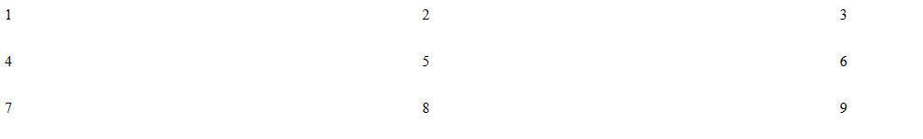
TID6  27/10/26 | Does the website display all 8 products in the correct grid format | N/A | Unit Test | Each product displayed in its grid slot with the relevant info. | 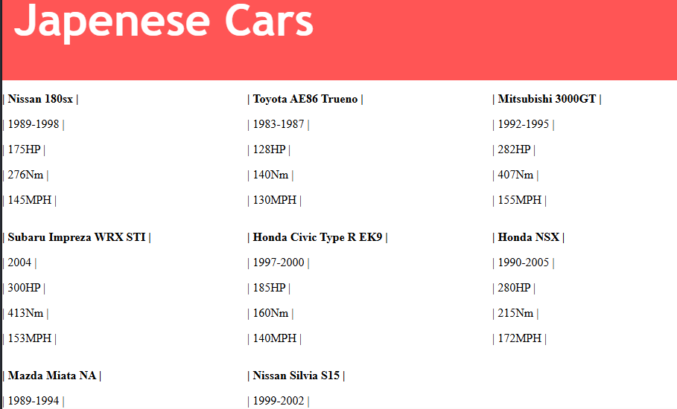
TID7  27/10/26 | Does the sorting algorithms work | N/A | Unit Test | Yes all 6 of the sorting algorithms work.
TID8  27/10/26 | Does the dropdown lead to a new display of sorted data | N/A | Unit test | No the alerts show but the grid is not populate again |  | SID4 shows research with Copilot to resolve this issue
TID9  27/10/26 | Does the dropdown correctly sort the data | N/A | Input + Unit test | Yes the dropdown does sort the products as intended | 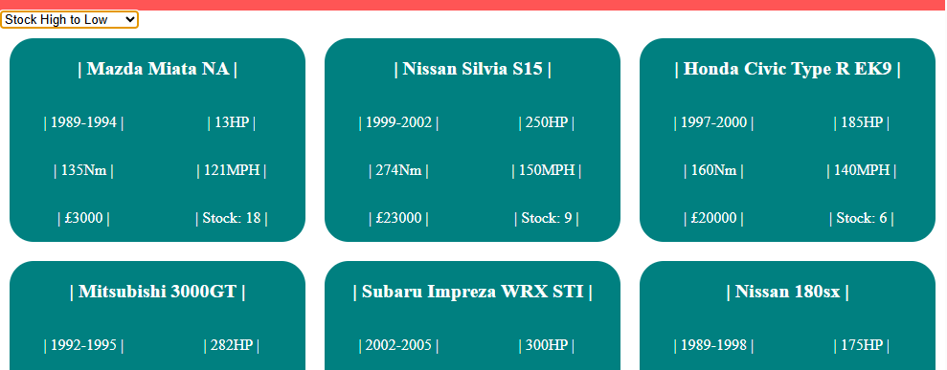
TID10  28/10/26 | Does the correct product id display in the alert along with an array of car names | Click of add to cart button | Input + unit test | Yes the alerts and code worked correctly | 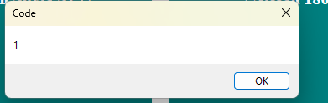  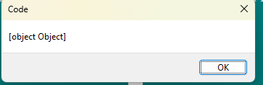 | The [object Object] resembles the json dictionary in the outputted array.
TID11  28/10/26 | Does the total price update under the cart | Clicks of different add to cart buttons | Input + unit test | Yes the total price does fully update successfully and accurately | 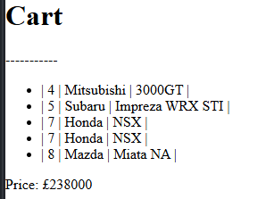 | The next change will be adding the individual pricing to the list items.

Source Log
Source ID | Source Name | Source | Comments
SID1  27/10/26 | Geeks For Geeks select tag | HTML select tag | Helped find out and understand the <optgroup> tag to organise the options
SID2  27/10/26 | Stack Overflow onchange event listener | Javascript: onchange or addEventListener? - Stack Overflow | Confirmed the existence of an ‘onchange’ event listener to be used on the select tag  Search: is there an on change event listener
SID3  27/10/26 |  |  | Search: how to sort json array in javascript
SID4  27/10/26 | Copilot | Share Link:  Why is this code not display a new sorted set of d | Shared Copilot Chat | The suggestions it made after I gave it my up to date code were helpful and allowed me to finish the functionality of the product sorting.

